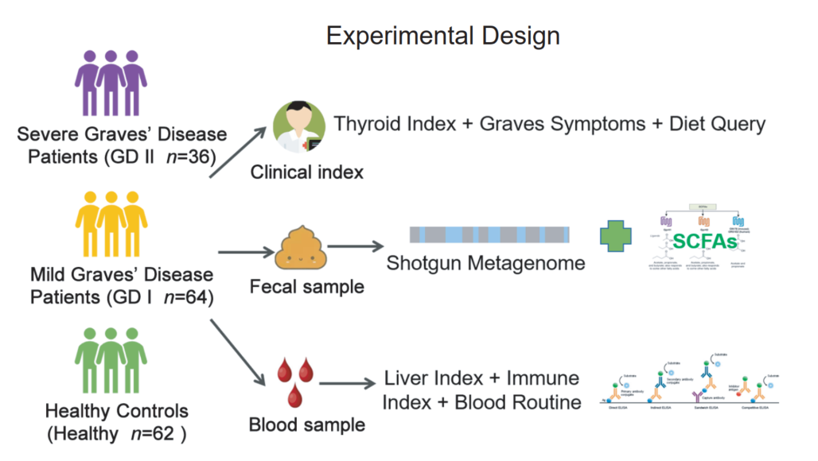

All subjects were recruited from the Hainan Provincial People's Hospital, Haikou, China. The subjects’ basic information (gender, age, BMI, smoking, and alcoholism) and clinical indexes were recorded in **Table S1**. The study was reviewed and approved by the Ethics Committee of the Hainan Provincial People's Hospital (2018-109), and informed consent was obtained from all volunteers in written form before they were enrolled in the study. Sampling and all described subsequent steps were conducted in accordance with the approved guidelines. Fecal samples were collected from each subject in the healthy group in the morning before the first meal. The cohort consisted of three groups: the healthy control group (Healthy, *n* = 62), the mild Graves’ disease patient group (GD I, *n* = 64) and the severe Graves’ disease patient group (GD II, *n* = 36) according to their thyroid-related diagnostic results (**Fig. 1A**). For each Graves’ disease patient, their fecal and blood samples were collected by a doctor during their clinical visit. After the weight of the fecal materials was determined, a sample protector (CW0592M, CWBIO, China) was added at a ratio of five-to-one to the sample to stabilize nucleotides. The samples were stored at -20 °C until further processing. Atotal of eleven clinical indexes including alanine aminotransferase (ALT), direct bilirubin, free triiodothyronine (FT3), free thyroxine (FT4), thyroid-stimulating hormone (TSH), thyroid peroxidase antibodies (TPOAb), thyroid-stimulating hormone receptor antibodies (TRAb) and immune indexes interleukin-17A (IL-17A) and IL-23 were determined by using the enzyme-linked immunosorbent assay (ELISA) method.